Academic Achievement
The Department of Education produces information about all schools on their website, our report can be found here https://www.compare-school-performance.service.gov.uk/school/125853/sidlesham-primary-school/primary
Due to the COVID pandemic, there were no formal assessments for the 2020-21 and 2021-22 academic years.

EARLY YEARS FOUNDATION STAGE PROFILE
Good Level of Development (GLD)
 | 2019 (%) | 2022 (%) | 2023 (%)
Sidlesham Primary School | 78.9 | 65 | 55
Local Authority (WSCC) | 71.9 | 64.4 | 67.5
National | 71.8 | 65.2 | 67.2

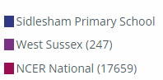
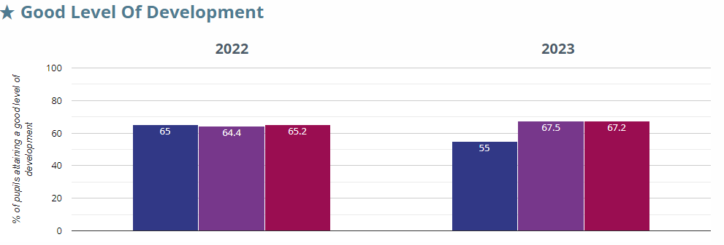

Average number of early learning goals at expected level per child
 | 2022 | 2023
Sidlesham Primary School | 14.9 | 14.4
Local Authority (WSCC) | 14.4 | 14.6
National | 14.1 | 14.1

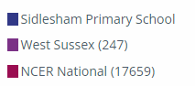
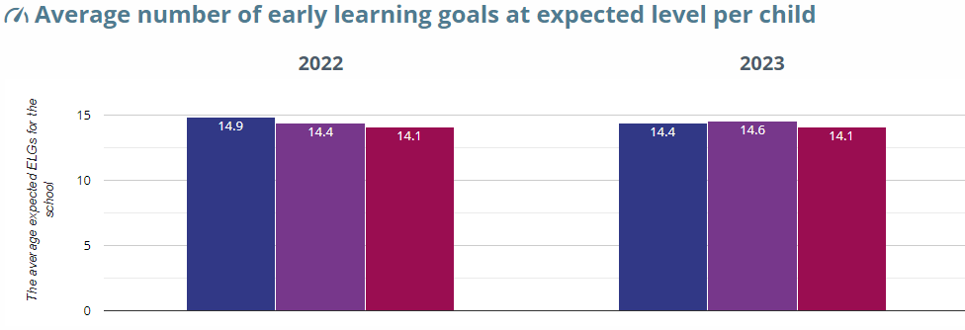

PHONICS
Year 1: Working At
Percentage of children that achieved the expected outcome or above in the statutory Year 1 Phonics Screening Check:
 | 2019 (%) | 2022 (%) | 2023 (%)
Sidlesham Primary School | 80 | 85.7 | 45
Local Authority (WSCC) | 80/8 | 74 | 77.7
National | 81.9 | 75.5 | 78.9

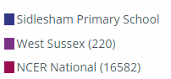
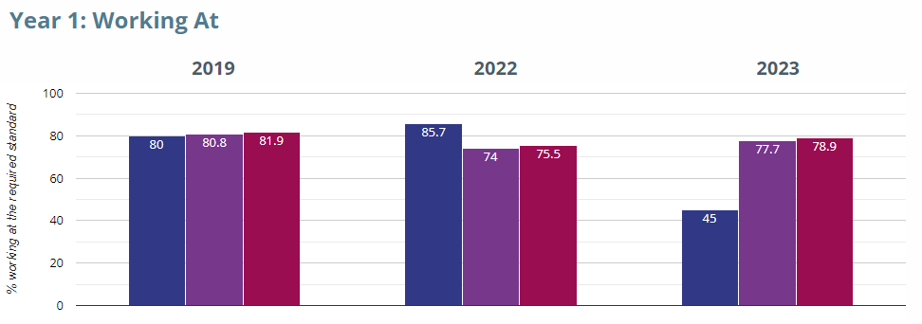

Percentage of children that achieved the expected outcome or above in the statutory Year 2 Phonics Screening Check (children who did not pass the Year 1 Phonics Screening Check):

Year 2: Working At
 | 2019 (%) | 2022 (%) | 2023 (%)
Sidlesham Primary School | 57.1 | 40 | 66.7
Local Authority (WSCC) | 56.7 | 43 | 58.1
National | 55.9 | 44.2 | 58.7

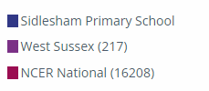
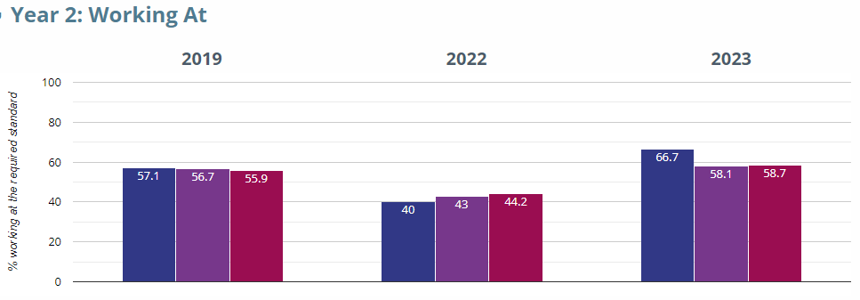

END OF KEY STAGE 1 OUTCOMES
Reading: Attaining at the Expected Standard or better
KS1 Reading (EXS or better) | 2019 (%) | 2022 (%) | 2023 (%)
Sidlesham Primary School | 45 | 55 | 57.1
Local Authority (WSCC) | 74.6 | 65.6 | 67.1
National | 74.9 | 66.9 | 68.2

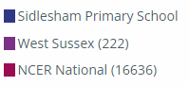
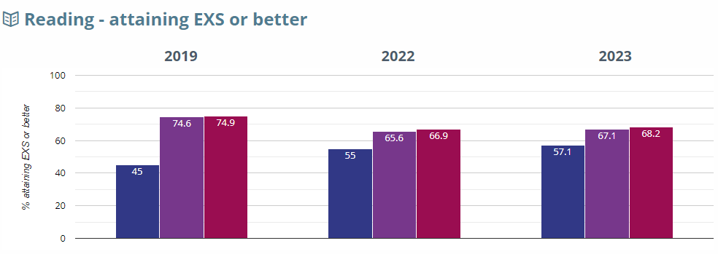

Reading: Attaining at the Greater Depth Standard (GDS)

KS1 Reading (GDS) | 2019 (%) | 2022 (%) | 2023 (%)
Sidlesham Primary School | 20 | 0 | 0
Local Authority (WSCC) | 20.7 | 12.7 | 14
National | 25 | 18 | 18.8

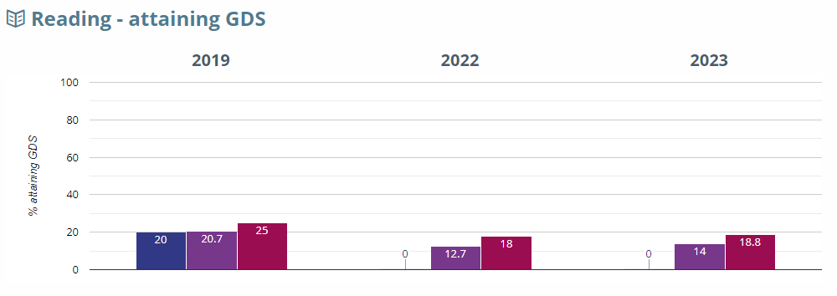

Writing: Attaining at the Expected Standard or better
KS1 Writing (EXS or better) | 2019 (%) | 2022 (%) | 2023 (%)
Sidlesham Primary School | 50 | 60 | 28.6
Local Authority (WSCC) | 67.5 | 52.5 | 56.1
National | 69.2 | 57.6 | 60.1

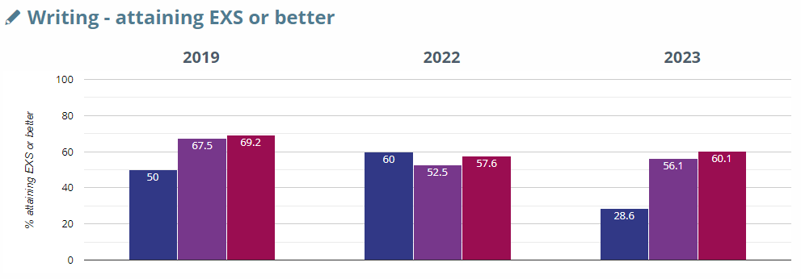

Writing: Attaining at the Greater Depth Standard (GDS)

KS1 Writing (GDS) | 2019 (%) | 2022 (%) | 2023 (%)
Sidlesham Primary School | 15 | 0 | 0
Local Authority (WSCC) | 10.6 | 4.5 | 4.9
National | 14.8 | 8 | 8.2

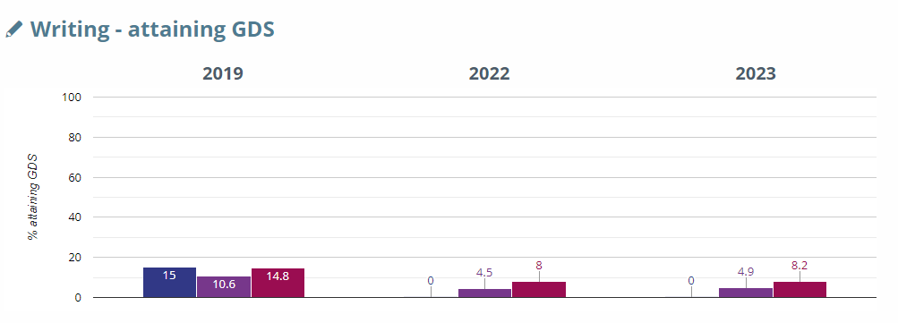

Maths: Attaining at the Expected Standard or better
KS1 Maths (EXS or better) | 2019 (%) | 2022 (%) | 2023 (%)
Sidlesham Primary School | 60 | 75 | 61.9
Local Authority (WSCC) | 74.1 | 64.3 | 68.5
National | 75.6 | 67.7 | 70.4

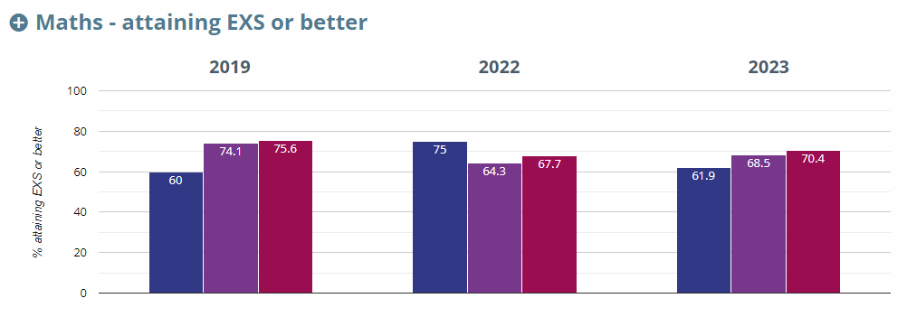

Maths: Attaining at the Greater Depth Standard (GDS)

KS1 Maths (GDS) | 2019 (%) | 2022 (%) | 2023 (%)
Sidlesham Primary School | 10 | 0 | 0
Local Authority (WSCC) | 17.2 | 9.1 | 11.4
National | 21.7 | 15.1 | 16.3

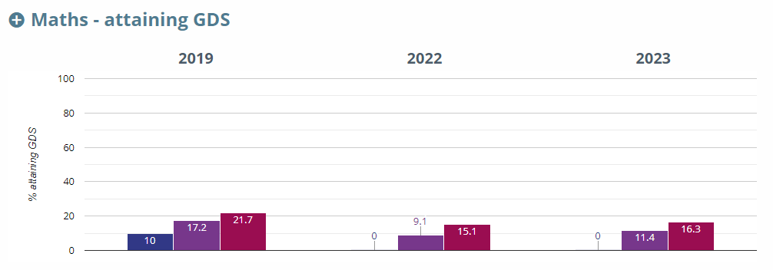

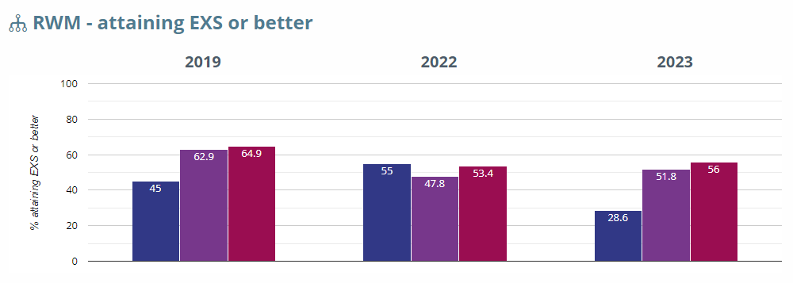

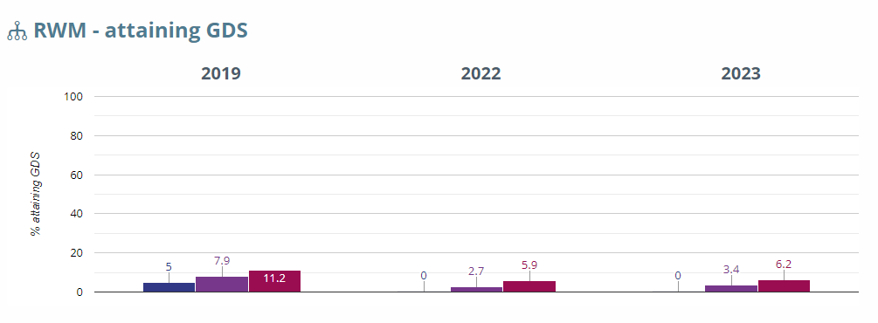

END OF KEY STAGE 2 OUTCOMES
Percentage of KS2 children that achieved the Expected Standard (EXS) and at the higher standard in reading, writing, grammar, punctuation and spelling (GPS) and maths:
KS2 Reading
KS2 Reading (EXS) | 2019 (%) | 2022 (%) | 2023 (%)
Sidlesham Primary School | 57.9 | 80 | 50
Local Authority (WSCC) | 73.4 | 74.4 | 72.4
National | 73.2 | 74.5 | 72.6

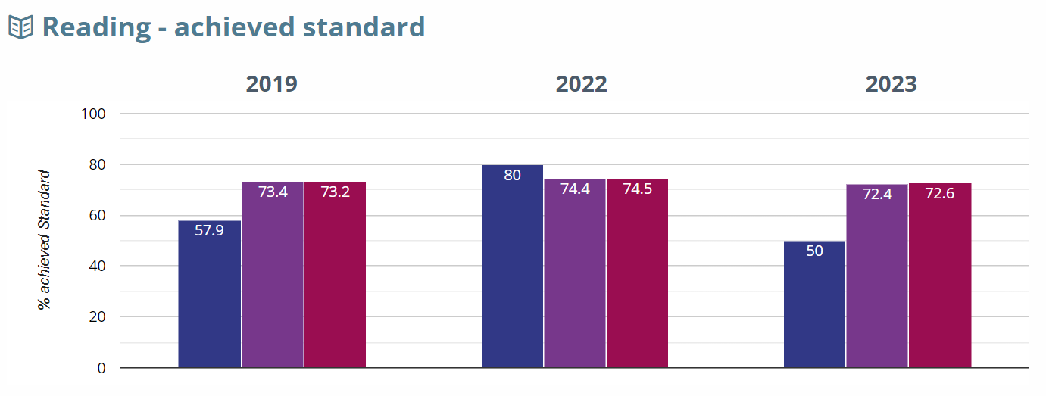
KS2 Reading (higher standard) | 2019 (%) | 2022 (%) | 2023 (%)
Sidlesham Primary School | 21.1 | 50 | 20
Local Authority (WSCC) | 27.3 | 27.6 | 29.2
National | 26.9 | 27.8 | 29

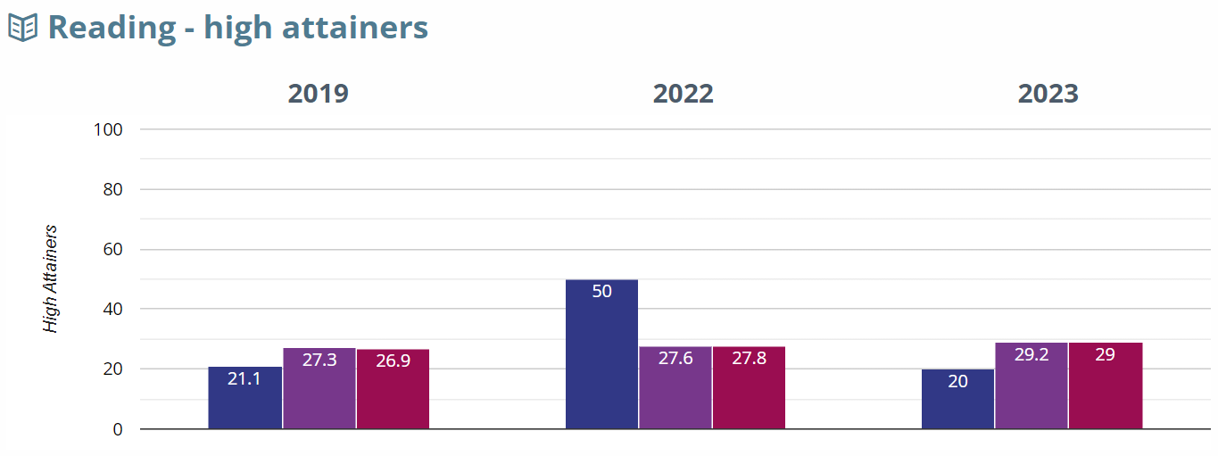

Reading Average Scaled Scores
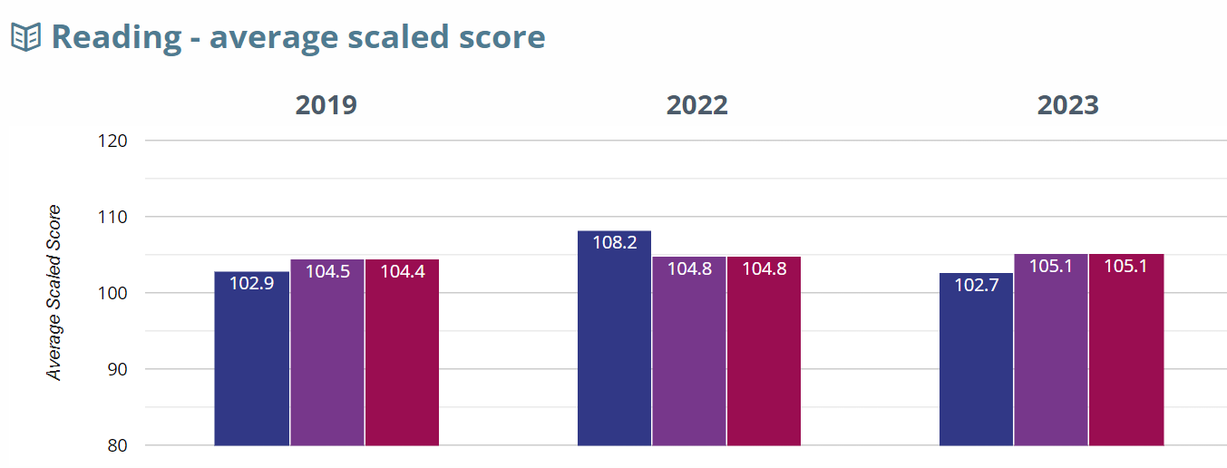

KS2 Writing
KS2 Writing (EXS) | 2019 (%) | 2022 (%) | 2023 (%)
Sidlesham Primary School | 78.9 | 70 | 50
Local Authority (WSCC) | 75.6 | 62.8 | 67.1
National | 78.5 | 69.5 | 71.5

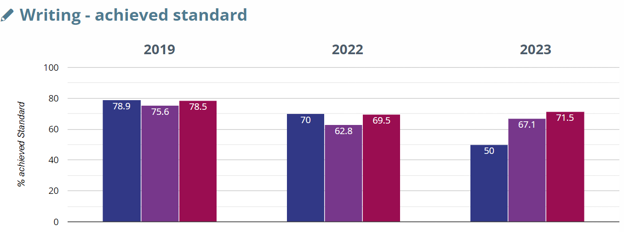

KS2 Writing (higher standard) | 2019 (%) | 2022 (%) | 2023 (%)
Sidlesham Primary School
Local Authority (WSCC)
National

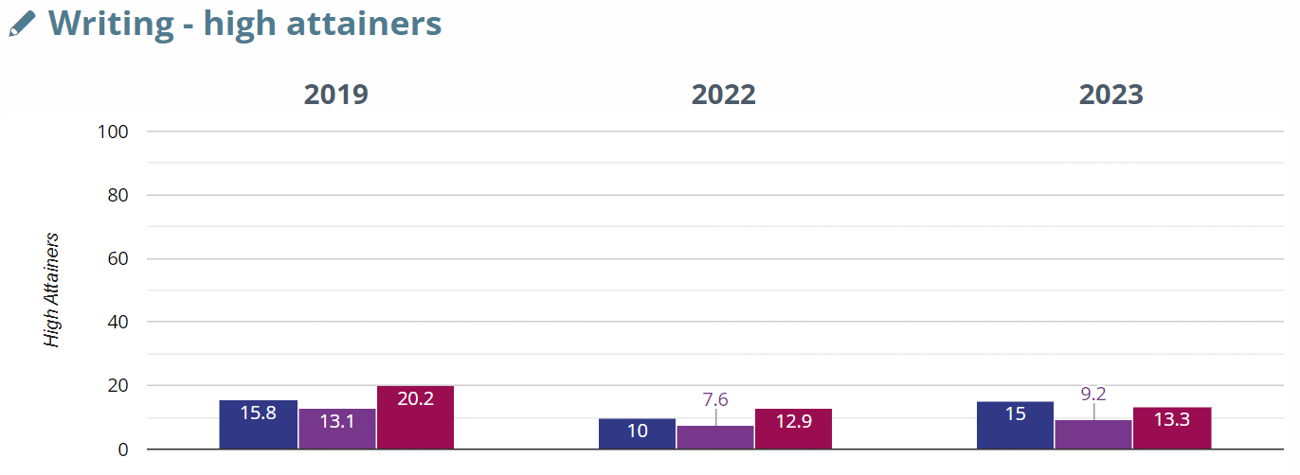

KS2 GPS (Grammar, punctuation, spelling)
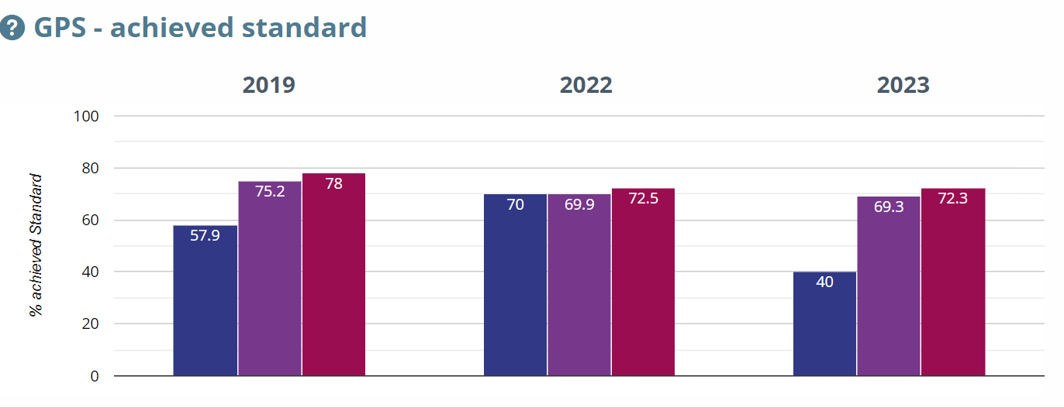

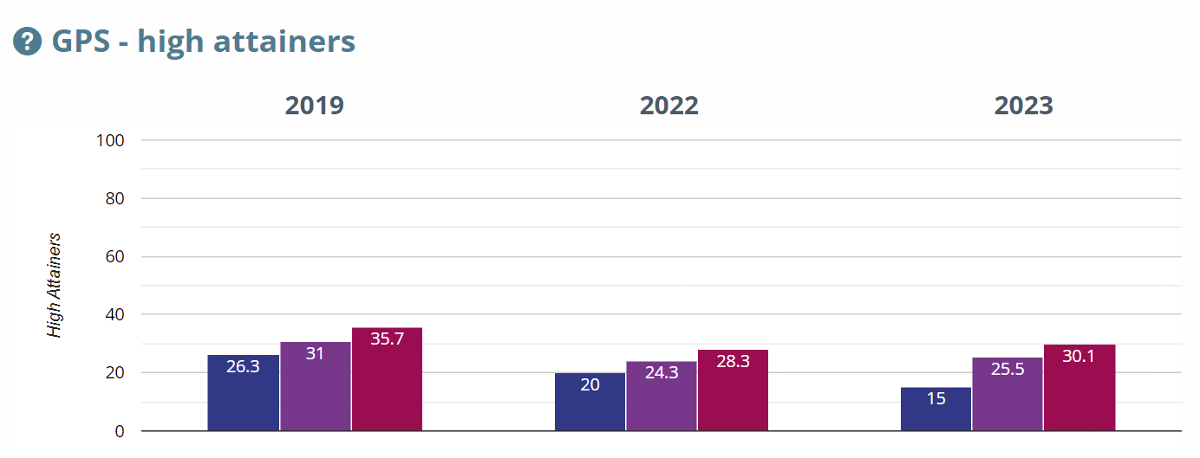

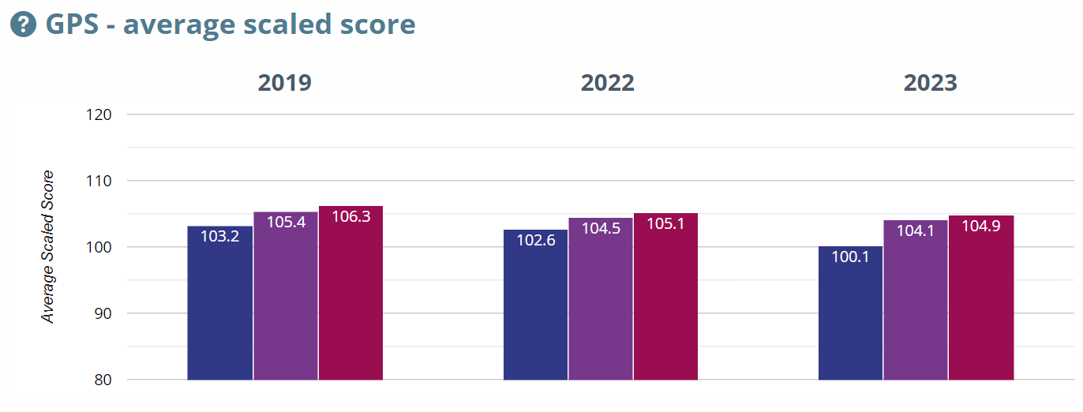

KS2 Maths
KS2 Maths (EXS) | 2019 (%) | 2022 (%) | 2023 (%)
Sidlesham Primary School | 68.4 | 60 | 45
Local Authority (WSCC) | 76.4 | 69.7 | 70.2
National | 78.7 | 71.4 | 72.9

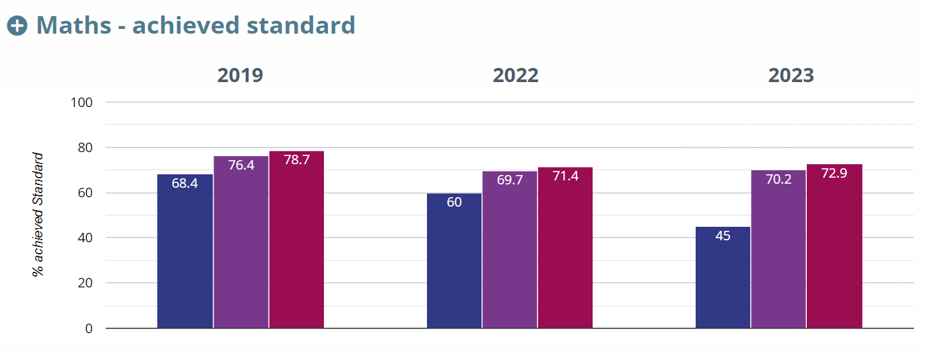

KS2 Maths (higher standard) | 2019 (%) | 2022 (%) | 2023 (%)
Sidlesham Primary School | 5.3 | 10 | 15
Local Authority (WSCC) | 22.9 | 19.4 | 20.4
National | 26.6 | 22.5 | 23.8

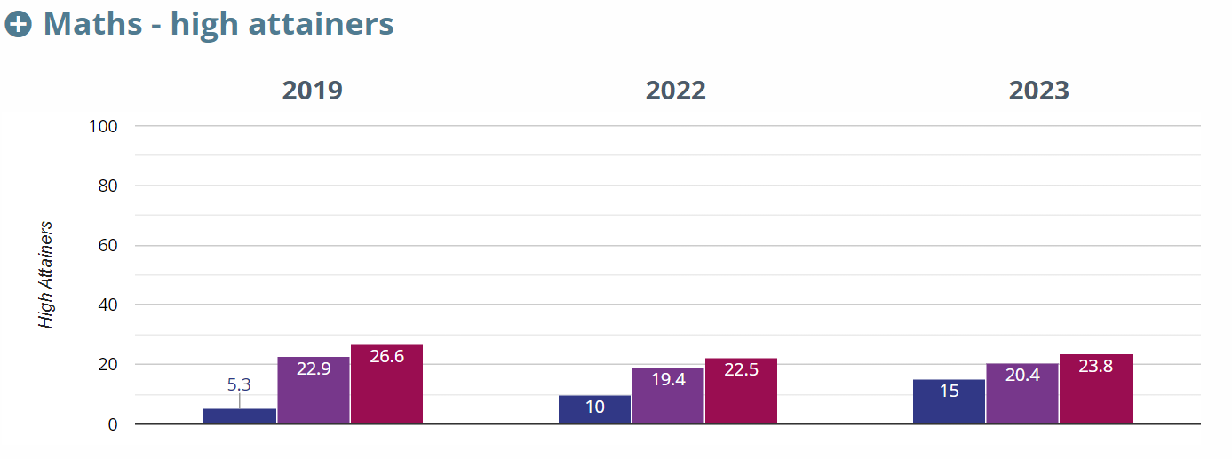

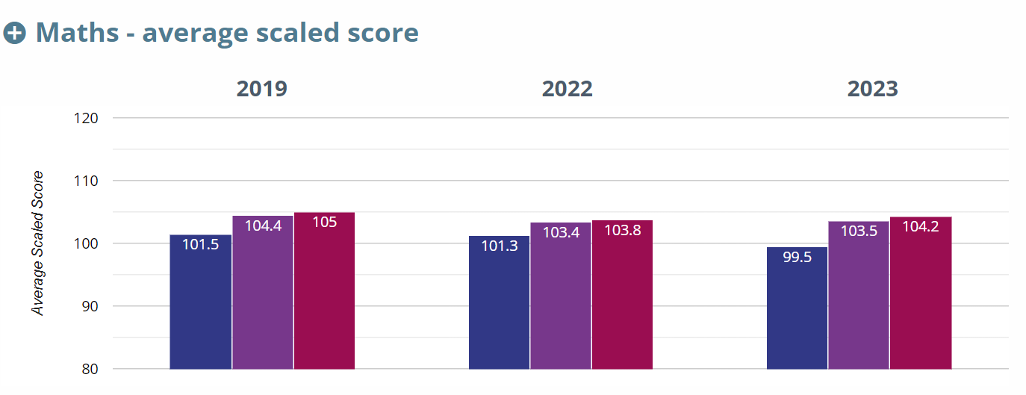

KS2 Reading, Writing and Maths (combined)
