BOREDOM BUSTERS

- Play keep up the balloon. Focus on stretching and big movements.
- Paint pictures – on paper or on the floor outside
- Have a go at Yoga or a dance routine on YouTube.
- Tie dye or paint t shirts. You can event print a design for these and have someone iron it on.
- Do the gardening
- Make jewellery (string and beads) if this is safe to do so.
- Make a life story about yourself. Or maybe a mood board of all the things you like!
- Make paper aeroplanes and boats. Race these. Use descriptive words to talk about what is happening. Try new designs and techniques i.e. fast or slow.
- Play musical games i.e. musical statues/musical chairs
- Do the cooking/baking
- Plan recipes – Look online at healthy recipes that can be tried
- Decorate the garden with chalk
- Make giant bubbles outside
- Have a sports day
- Have a disco
- Do a virtual tour online – you could visit a zoo or a museum!
- Do a music making game online: https://musiclab.chromeexperiments.com/
- Treasure hunt
- Indoor/garden picnic
- Skittles or throwing balls into baskets
- Indoor beanbag curling
- Do a workout video online i.e. Joe Wicks on YouTube.

Please note: All activities need to be risk assessed in line with local policies and procedures.

1. Keep up the balloon | 2. Paint pictures | 3. Yoga/Dance routine
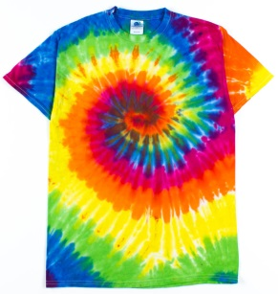  4. Tie dye / paint shirts | 5. Gardening  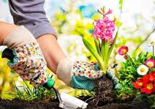 | 6. Make jewellery  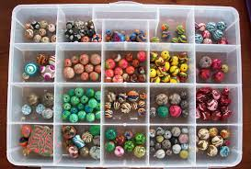
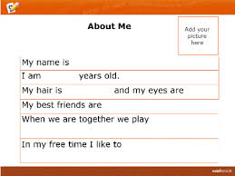  7. Write about `me` | 8. Paper aeroplanes  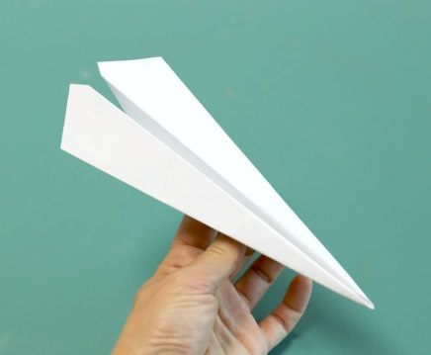 | 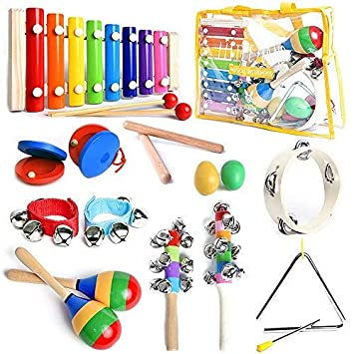  9. Musical games
10. Cooking / Baking | 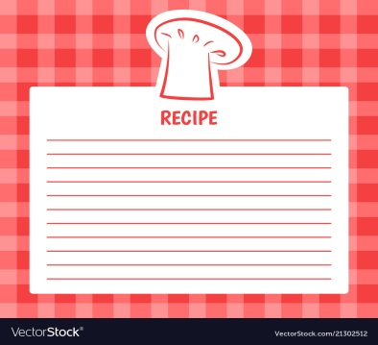  11. Plan recipes | 12. Chalk in garden  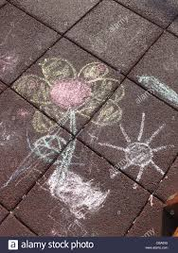
13. Giant bubbles | 14. Sports day | 15. Disco

