15th March 2024

Dear Parents and Carers,

Newsletter

Annual reports to parents/carers
Next Friday your child will bring home their annual report written by their class teacher along with their attendance record for this academic year so far.

Parents/Carers evening appointments
We are looking forward to welcoming parents/carers into school for parents' evenings on 26th/27th March. If you have not yet booked your appointment, please contact the office as soon as possible as there is limited availability. Appointments for Tigers are for Wednesday only.

Mrs Koiston's visits to school
We were delighted to welcome Mrs Koiston to school this week to begin the transition and handover process with myself and staff. She was also able to visit classes to speak with children. She will also be visiting school on 21st and 27th March and is looking forward to meeting some of you at the beginning/end of the day and will be around at Parents Evening on 27th March.

Tigers trip to Aldingbourne Centre
What a wonderful time Tigers class had meeting the farm animals yesterday, even feeding the alpacas and making friends with Hercules the turkey! The children enjoyed their time in the woodland area and in the maze too! It was a wonderful way to bring their learning alive from their topic 'Come Outside.'

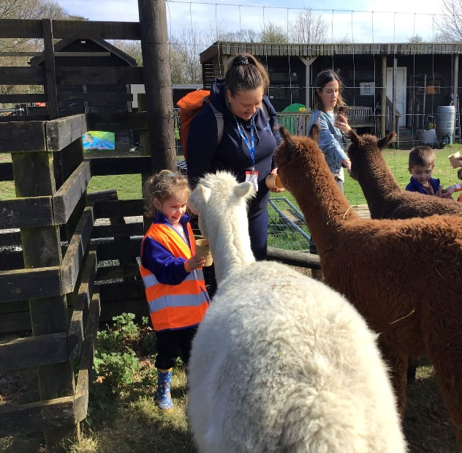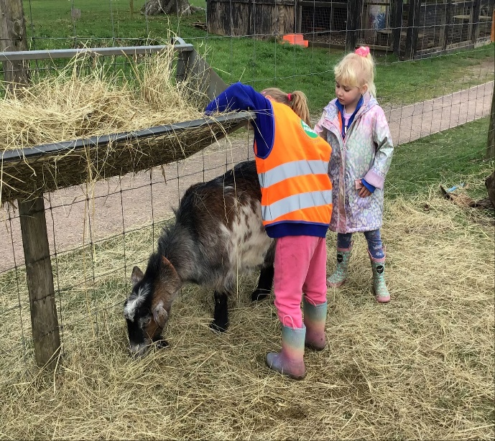

Dates for your diary

Year SATS parent/carer meeting | Monday 25th March 3.10pm
Annual reports | Friday 22nd March
Parent/Carer/teacher Consultation Evenings | Tuesday 26th March & Wednesday 27th March 3:30pm - 6:00pm  Tigers on Wednesday only
Last day of term | Thursday 28th March
Start of Summer Term | Monday 15th April

With very best wishes

Mrs Norton
Interim Headteacher

