Dear Parents and Carers

Newsletter - 13th October 2023

Harvest Festival
My thanks to so many of you for your donations to our Harvest Festival. It was wonderful to see such generosity during these times when so many are struggling with the cost of living. The Year 6 children who helped organise the display of donations commented that there seemed to be far more sent in than in the last couple of years: so, once again a sincere ‘Thank you’ from me and the Chichester Foodbank.
It was lovely to have Father Chris in with us for the occasion helping us all to focus on being thankful and ways that we could show that thankfulness too.

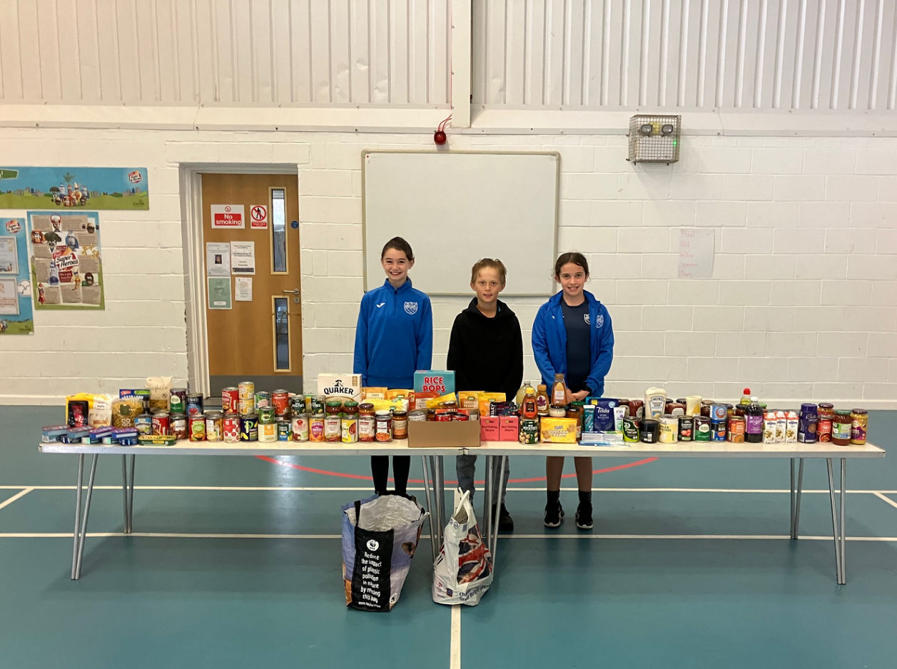

Illness
Speaking of thankfulness, we have been suffering with an awful lot of illness sweeping through the school, which has not only meant that attendance is down, but that we have been rather short of staff too - so I am again hugely thankful to those of you who have volunteered to help out in school throughout this time. I am impressed with the way the children have coped with changes in teachers and teaching assistants as a result and am most grateful to everyone who has staffed the office at some point too (Mrs Merrett, Father Chris and Miss Harwood)!

Staffing news
I am pleased to report that we have had a very strong field for the teaching role in Meerkats and that I have verbally offered this position today. I shall announce who the teacher is once the paperwork has been duly completed. But thought you’d be pleased to know that is one conundrum for the school almost resolved. I fully expect them to be taking the class after half-term.

Have a good weekend,
Mr Bird

Dates for your diary

Parents Evening - Tuesday 17th October @ 3:30 - 6pm and Wednesday 18th October @ 3:30 - 6pm
Inset Day - Friday 20th October
Half Term - Monday 23rd to Friday 27th October
Open Days for Year R 2024 - Tuesday 31st October @ 2pm and Wednesday 1st November @ 10am
Spooky Disco - Friday 3rd November (PTA run - details to follow)
Children in Need - Wear something spotty and competitions to be confirmed
School Photos (individual) - Wednesday 15th November
Anti-Bullying Week - Monday 13th to Friday 17th November
Non-Uniform Day in support of the Christmas Fair - Thursday 23rd November
Christmas Fair - Friday 1st December
Christmas Jumper Day - Thursday 7th December
Nativity - Tuesday 12th December @ 2pm and Wednesday 13th December @ 10am and 5pm
Christmas Lunch - Thursday 14th December
Last day - 15th December

