Week Commencing 16.3.20

Home Topic Grid

Research and find out 10 things about the Blitz | Can you find a daffodil in the garden? If you are allowed dissect it!  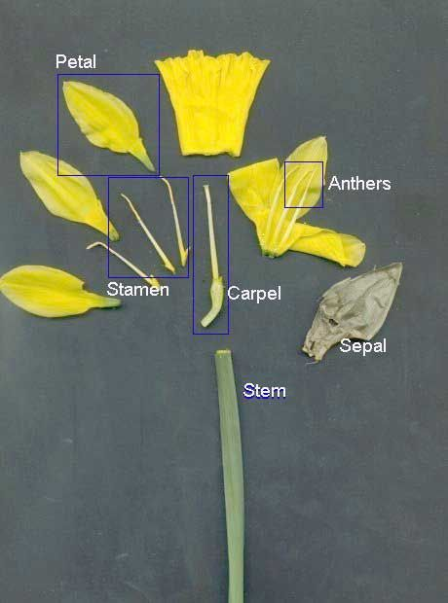 | Use the internet to research how to write your name in Morse Code!
Draw and label a Spitfire | Research British fashion during WWII | Go out into the garden or look out the window – how many different trees can you identify? Are any of them in blossom?

